SIMATS ENGINEERING ch .Abhilash reddy
192525462
ASSESSMENT TOOL 1
COURSE NAME: INTERNET PROGRAMMING
COURSE CODE: CSA4303
COURSE OUTCOME COVERED
CO-1: Develop well-structured, standards-compliant web pages using HTML/XHTML and XML, and apply Internet protocols and HTTP communication mechanisms for web content delivery. (L2)
Assessment Tool: Application-Based Questions
Weightage: 40%
QUESTIONS: Total Marks: 30
1: Online Symposium Portal
A college is developing an online symposium registration portal. The following HTML structure and HTTP interaction is observed:
<form action="/register" method="POST">
<input type="text" name="name">
<input type="email" name="email">
<button>Submit</button>
</form>
When a student submits the form, the browser sends an HTTP request to the server, and the server responds accordingly.
Questions:
1. Identify appropriate HTML5 semantic elements missing in the structure. 2. Modify the structure to make it standards-compliant.
3. Interpret the HTTP request generated during form submission.
4. Analyze the HTTP response cycle from server to browser.
5. Suggest improvements for usability and accessibility.
2: Cross-Browser Compatibility Issue
A company website shows inconsistent layout across browsers. The following HTML snippet is used:
<html>
<head>
<title>Company</title>
</head>
<body>
<div>
<h1>Welcome
<p>About us
</div>
</body>
</html>
Questions:
1. Identify improper nesting and missing closing tags.
2. Analyze how different browsers may interpret this structure.
3. Identify missing semantic elements (e.g., header, section).
4. Provide a corrected W3C-compliant HTML structure.
5. Suggest techniques to ensure cross-browser compatibility.
3: Form Submission Failure
A web application fails to send form data to the server. The following configuration is observed:
<form action="/submit" method="GET">
<input type="text" name="username">
<input type="password" name="password">
<button type="button">Login</button>
</form>
Questions:
1. Identify issues in the form configuration.
2. Analyze why the HTTP request is not triggered.
3. Interpret the role of GET method in this scenario.
4. Propose a corrected implementation.
5. Suggest improvements for secure data transmission.
Code of Conduct:
I ch.Abhilash Reddy(192525462) (Name / Reg No) certify that this submission is my original work and that I have adhered to the guidelines specified for this assessment. I understand that any violation of academic integrity rules will result in disciplinary.
Signature of the student: abhilash reddy

RUBRICS FOR CALCULATION:
Criteria | Weig  htage | Level 4 –  Exemplary | Level 3 –  Proficient | Level 2 –  Developing | Level 1 –  Beginning | Marks
Understanding of Concepts | 25% | Demonstrates  thorough, accurate understanding of  concepts | Good  understanding with minor gaps | Basic  understanding with some  misconception s | Poor  understandin g; major  misconceptio ns | 21.25
Explanation | 25% | Detailed, well  explained answers with relevant  examples | Clear  explanation with adequate  details | Limited  explanation;  lacks depth | Poor or  unclear  explanation | 21.25
Application | 20% | Effectively applies concepts with strong analytical ability | Applies  concepts with minor errors | Limited  application  with weak  analysis | No  application or incorrect  analysis | 17.00
Organization | 15% | Well-structured  answers with logical flow and coherence | Organized with minor issues in flow | Basic  structure,  lacks clarity | Poor  organization, incoherent  answers | 12.75
Accuracy | 10% | Completely accurate and covers all  required points | Mostly accurate with minor  omissions | Partially  correct with  missing points | Incorrect  answers with major gaps | 8.50
Clarity | 5% | Clear, neat,  professional  presentation | Understandable with minor  issues | Limited clarity, readability  issues | Poorly  written,  difficult to  understand | 4.25

Total 85 marks

Scenario-Based Questions and Answers

I. Online Symposium Portal
1. Identify appropriate HTML5 semantic elements missing in the structure.
The given form contains input fields, but it does not show a complete and meaningful page structure. HTML5 semantic elements explain the purpose of different parts of a webpage. The <header> element can contain the page title, <main> can contain the main content, and <section> can group the registration form. A <footer> can be added for contact or copyright information. Each input should also have a <label> so students can understand what information to enter. These elements improve readability, accessibility, and page organization.
2. Modify the structure to make it standards-compliant.
The code should include the HTML5 doctype, a language attribute, character encoding, a page title, correctly nested elements, and labels for the form fields. The required attributes can also help prevent empty submissions. Example:
<!DOCTYPE html>
<html lang="en">
<head>
<meta charset="UTF-8">
<meta name="viewport" content="width=device-width, initial-scale=1.0">
<title>Symposium Registration</title>
</head>
<body>
<header>
<h1>Online Symposium Registration</h1>
</header>
<main>
<section>
<h2>Student Registration</h2>
<form action="/register" method="POST">
<label for="name">Full Name:</label>
<input type="text" id="name" name="name" required>
<label for="email">Email Address:</label>
<input type="email" id="email" name="email" required>
<button type="submit">Submit</button>
</form>
</section>
</main>
<footer>
<p>Symposium Registration Portal</p>
</footer>
</body>
</html>
3. Interpret the HTTP request generated during form submission.
When a student enters the name and email address and clicks Submit, the browser collects the named form fields and sends an HTTP request to the server. Since the form uses method="POST", the request is sent to the /register path and the form values are normally placed in the request body rather than in the URL. The request also contains headers that describe the browser and the content format. The server uses the request path to identify the registration endpoint, reads the submitted values, and validates them. The name and email are included only if the controls have name attributes and are successful form controls. POST does not by itself encrypt information; HTTPS is needed to protect it during transmission.
4. Analyze the HTTP response cycle from server to browser.
First, the browser sends the POST request to the web server. The server routes the request to the registration handler and validates the submitted details. If the information is valid, the server may save the registration in a database and prepare a confirmation response. If the information is missing or invalid, it may return an error message asking the student to correct the form. The HTTP response includes a status code, headers, and usually a response body. For example, 200 OK indicates success, 400 Bad Request can indicate invalid input, and 500 Internal Server Error indicates a server-side problem. The browser receives the response and displays the confirmation page or error message to the student.
5. Suggest improvements for usability and accessibility.
The form should use visible labels associated with their input fields, required attributes where appropriate, and clear instructions about the expected information. Error messages should explain how to fix a problem instead of only saying that submission failed. The form should be usable with a keyboard, screen reader, and mobile device. Use appropriate autocomplete values, keep the layout simple, and show a confirmation after successful registration. For security, use HTTPS and validate all submitted data on the server as well as in the browser.
output:
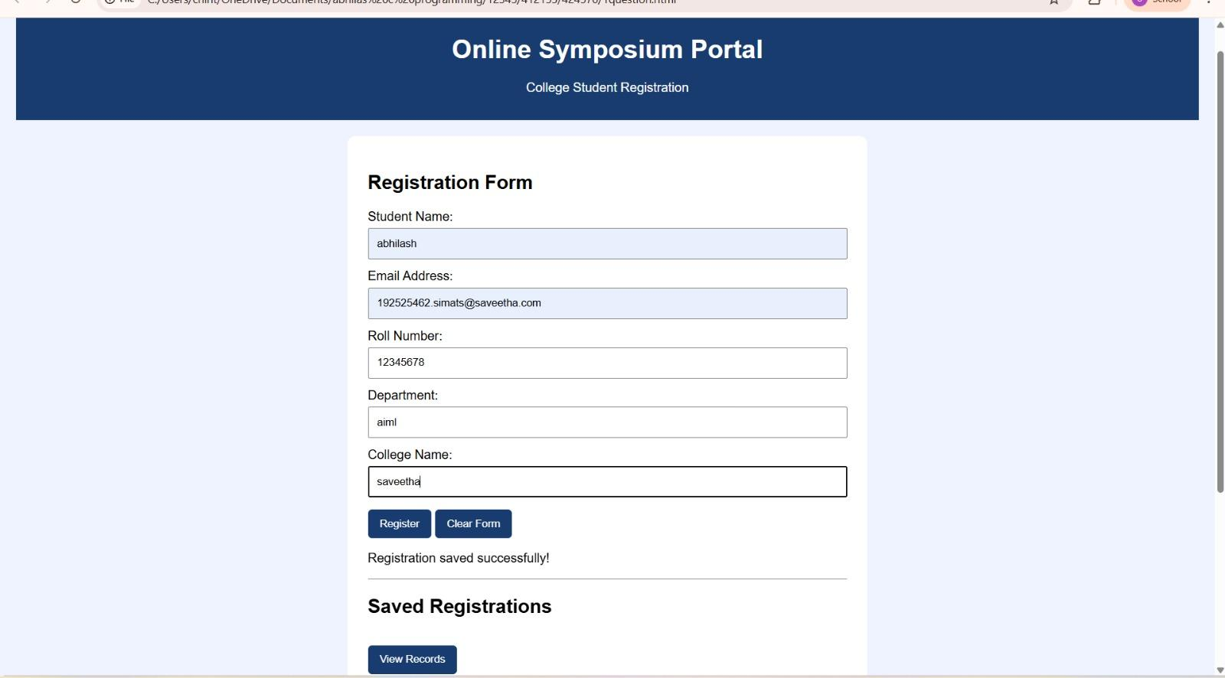

II. Cross-Browser Compatibility Issue
1. Identify improper nesting and missing closing tags.
The supplied HTML snippet has an opening <h1> tag without a matching closing </h1> tag and an opening <p> tag without a closing </p> tag. The document also lacks the <!DOCTYPE html> declaration and the lang attribute on the html element. Character encoding and viewport metadata are also missing. HTML elements should be nested in the correct order and closed where required so browsers can build a predictable document structure.
2. Analyze how different browsers may interpret this structure.
Modern browsers attempt to recover from invalid HTML so that a page can still be displayed. However, browsers may repair malformed markup in different ways or produce a document tree that is not what the developer intended. This can affect heading and paragraph spacing, CSS selectors, JavaScript behavior, and accessibility tools. Relying on automatic browser repair makes the result harder to predict and test. Valid markup reduces these differences.
3. Identify missing semantic elements (e.g., header, section).
The page uses a generic <div> even though the content has clear roles. A <header> can hold the Welcome heading, <main> can identify the primary content, and <section> can group the About Us information under its own heading. A <footer> is appropriate if the page has copyright, contact, or other footer information. Semantic elements make the document easier to understand for developers, search engines, and assistive technologies.
4. Provide a corrected W3C-compliant HTML structure.
A corrected structure includes the HTML5 doctype, language, metadata, a title, and properly closed elements. For example:
<!DOCTYPE html>
<html lang="en">
<head>
<meta charset="UTF-8">
<meta name="viewport" content="width=device-width, initial-scale=1.0">
<title>Company</title>
</head>
<body>
<header>
<h1>Welcome</h1>
</header>
<main>
<section>
<h2>About Us</h2>
<p>Learn more about our company and services.</p>
</section>
</main>
</body>
</html>
5. Suggest techniques to ensure cross-browser compatibility.
Use valid HTML and CSS and check the markup with the W3C HTML Validator. Test the site in major browsers such as Chrome, Firefox, Edge, and Safari, as well as at different screen sizes. A CSS reset or normalize stylesheet can reduce differences in default styles. Prefer widely supported features, use feature detection when necessary, and apply responsive design. Testing after changes helps identify layout or behavior problems before the site is published.


III. Form Submission Failure
1. Identify issues in the form configuration.
There are two important problems in the given form. First, the button is written as <button type="button">Login</button>. A button with type="button" does not submit the form automatically, so clicking it will not send the form data unless JavaScript has been added to handle the click. Second, the form uses method="GET" while collecting a password. GET adds submitted form values to the URL, which can expose sensitive information in browser history, server logs, or copied links. The form also needs labels and required-field validation for better usability.
2. Analyze why the HTTP request is not triggered.
When the user clicks the Login button, the browser sees type="button" and treats it as a general button rather than a form-submission control. Therefore, the browser does not perform the normal form submission and does not send the request to /submit. The simplest fix is to change the button type to submit. If a JavaScript-based submission is intended instead, a click or submit event handler must be written correctly, but that is not shown in the supplied code.
3. Interpret the role of GET method in this scenario.
GET is designed mainly for requesting or retrieving information from a server. When used for a form, the browser normally appends the named values to the URL as query parameters, such as /submit?username=student. This is useful for search forms because the URL can be bookmarked or shared. It is not appropriate for passwords or other sensitive data, because the values may appear in browser history, logs, and copied URLs. GET also has practical URL-length limits. A login form should normally use POST over HTTPS. POST places form values in the request body, but HTTPS is still required for encryption.
4. Propose a corrected implementation.
The following version uses POST, labels, required fields, and a submit button. The server endpoint /submit must also be configured to accept and process POST requests.
<!DOCTYPE html>
<html lang="en">
<head>
<meta charset="UTF-8">
<meta name="viewport" content="width=device-width, initial-scale=1.0">
<title>Login Page</title>
</head>
<body>
<main>
<h1>Login</h1>
<form action="/submit" method="POST">
<label for="username">Username:</label>
<input type="text" id="username" name="username"
autocomplete="username" required>
<label for="password">Password:</label>
<input type="password" id="password" name="password"
autocomplete="current-password" required>
<button type="submit">Login</button>
</form>
</main>
</body>
</html>
5. Suggest improvements for secure data transmission.
Use HTTPS so information is encrypted while travelling between the browser and server. Use POST for login form submission, but remember that POST alone does not encrypt the data. Validate input on the server, store passwords only with a suitable password-hashing algorithm, and never save passwords as plain text. Use secure session cookies, limit repeated login attempts, and provide general error messages that do not reveal whether a username exists. Keep the server and its dependencies updated and protect authenticated pages with proper session management.

Output:
